**What is a Variable?**

**In computer science, a variable is a location for storing a value which can be a filename, text, number or any other data. It is usually referred to with its Symbolic name which is given to it while creation. The value thus stored can be displayed, deleted, edited and re-saved.**

**Variables play an important role in computer programming because they enable programmers to write flexible programs. As they are related to the Operating system that we work on, it is important to know some of them and how we can influence them.**

========================

**What are Environment variables?**

**Environment variables are dynamic values which affect the processes or programs on a computer. They exist in every operating system, but types may vary. Environment variables can be created, edited, saved, and deleted and give information about the system behaviour.**

**Environment variables can change the way a software/programs behave.**

**E.g. $LANG environment variable stores the value of the language that the user understands. This value is read by an application such that a Chinese user is shown a Mandarin interface while an American user is shown an English interface.**

**some common environment variables:**

|  |  |  |
| --- | --- | --- |
| **Variable** | **Description** |  |
| **PATH** | This variable contains a colon (:)-separated list of directories in which your system looks for executable files. |  |
| [Linux - Environment Variables](https://www.guru99.com/images/echoPath.png) |  |
|  |
| When you enter a command on terminal, the shell looks for the command in different directories mentioned in the $PATH variable. If the command is found, it executes. Otherwise, it returns with an error 'command not found'. |  |
| **USER** | The username |  |
| **HOME** | Default path to the user's home directory |  |
| **EDITOR** | Path to the program which edits the content of files |  |
| **UID** | User's unique ID |  |
| **TERM** | Default terminal emulator |  |
| **SHELL** | Shell being used by the user |  |

**Accessing Variable values**

**In order to determine value of a variable, use the command:  #echo $VARIABLE_NAME**

**Variables are- Case Sensitive. Make sure that you type the variable name in the right letter case otherwise you may not get the desired result**s

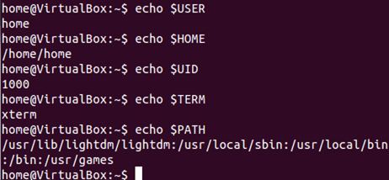

The '**env'** command displays **all the environment variables.**

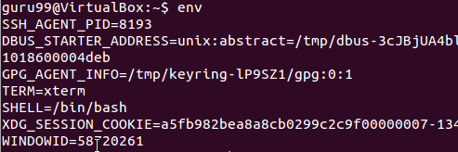

## How to Set New Environment Variables????

## You can create your own user defined variable, with syntax as below::

## VARIABLE_NAME = variable_value

## Bear in mind **that variables are case-sensitive** and usually they are created in upper case only!!!

## Linux - Environment Variables

## Deleting Variables

**The following syntax can be used to remove a Variable from the system.**

**#unset VARIABLE_NAME**

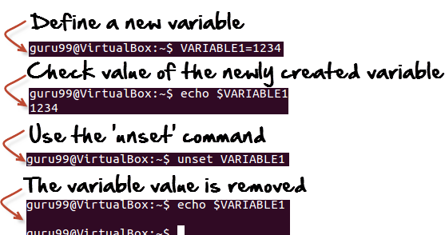

**Environment variables govern the behaviour of programs in your Operating System.**

|  |  |
| --- | --- |
| **Command** | **Description** |
| echo $VARIABLE | To display value of a variable |
| env | Displays all environment variables |
| VARIABLE_NAME= variable_value | Create a new variable |
| unset | Remove a variable |
| export Variable=value | To set value of an environment variable |

**To add variables permanently(persistent on Reboot need to add under profile:**

**/etc/profile**  -  Contains system void variables, effect administrator & local user profiles. It includes files under /etc/profile.d/*.sh

**~/.bash_profile** -  it contains user specific variables only

### **/etc/profile.d/*.sh**

Files with the .sh extension in the **/etc/profile.d** directory get executed whenever a bash login shell is entered (e.g. when logging in from the console or over ssh), as well as by the DisplayManager when the desktop session loads.

While **/etc/profile** is often suggested for setting environment variables system-wide, it is a configuration file of the base-files package, so it's not appropriate to edit that file directly. Use a file in **/etc/profile.d** instead as shown above.

All large user and site specific environment customization should be placed in this directory. All scripts in this directory called by [/etc/profile](https://bash.cyberciti.biz/guide/etc/profile)

**for** i in /etc/profile.d/*.sh ; **do**

**if** [ -r "$i" ]; **then**

. $i

**fi**

**done**